**CORONA VIRUS REPORT QUERY DOCUMENT**

**BATCH NUMBER – MIP-DA-07**

**QUERY QUESTIONS (KPI’s)**

1. **Write a code to check NULL values**



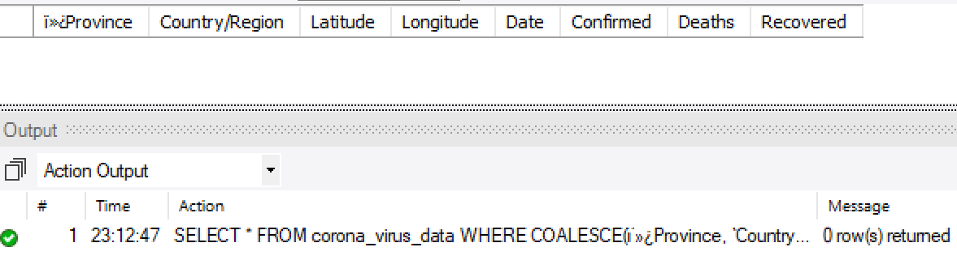

1. **If NULL values are present, update them with zeros for all columns.**

**Data had no NULL value.**

1. **Check total number of rows**

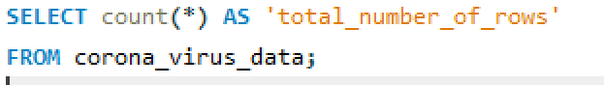

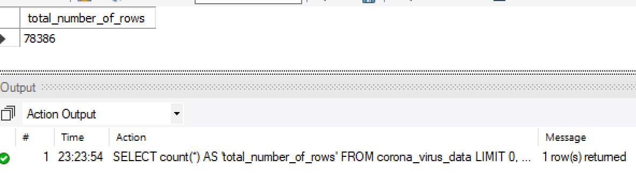

1. **Check what is start_date and end_date**

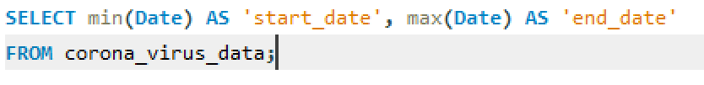

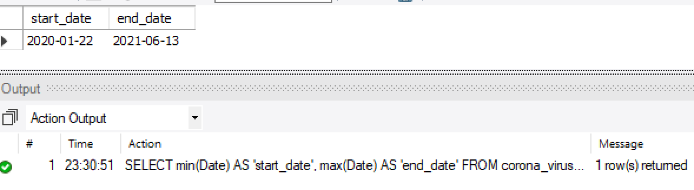

1. **Number of months present in dataset**



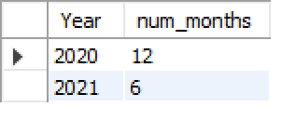



1. **Find monthly average for confirmed, deaths, recovered**

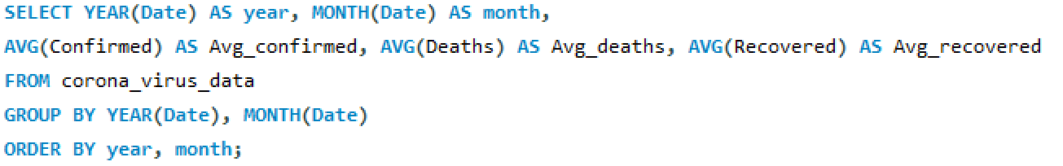

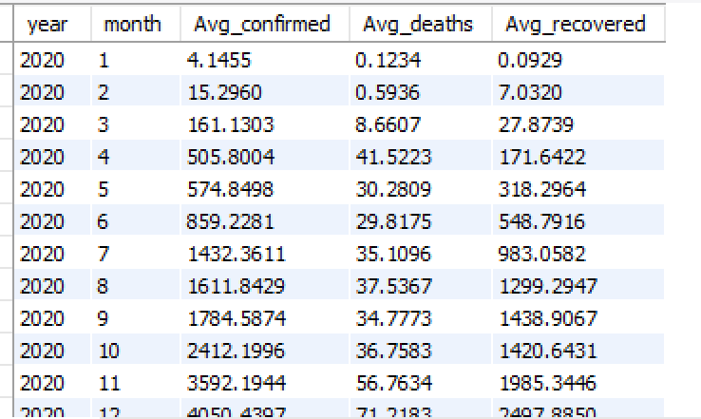

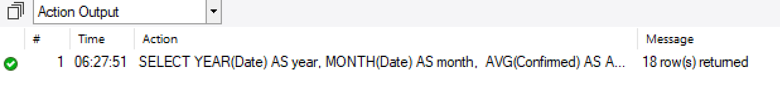

1. **Find most frequent value for confirmed, deaths, recovered each month**
2. ***frequent value for confirmed cases***

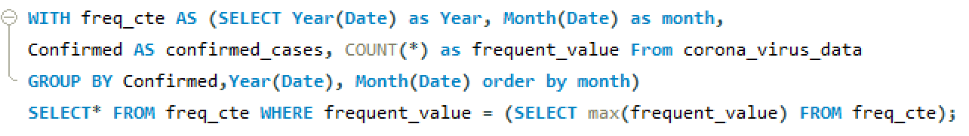

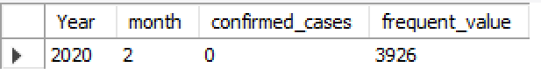

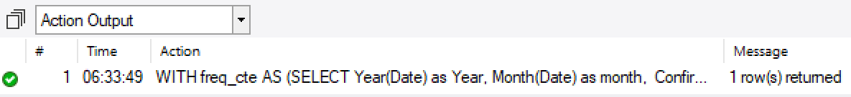

1. ***frequent values for death cases***

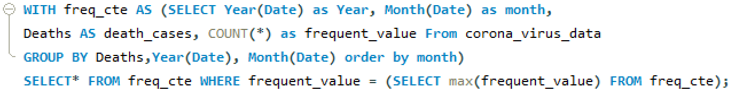

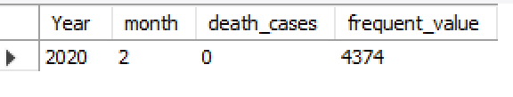

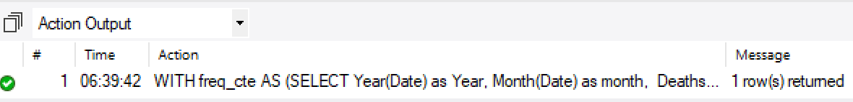

1. ***frequent values for recovered cases***

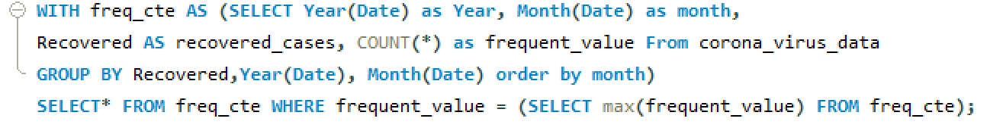

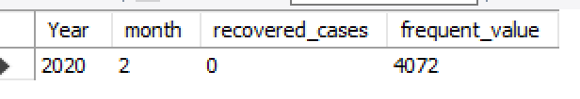

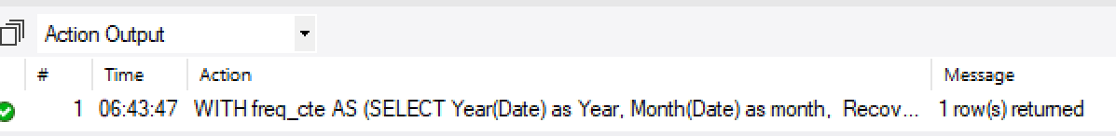

1. **Find minimum values for confirmed, deaths, recovered per year**

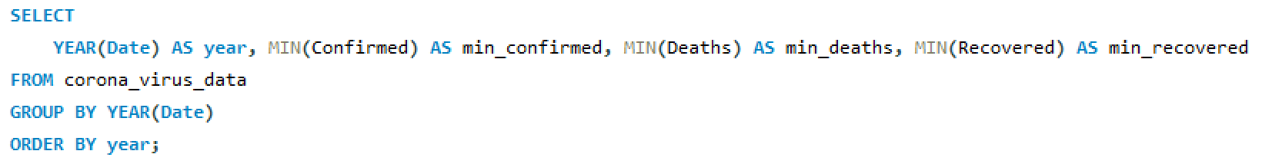

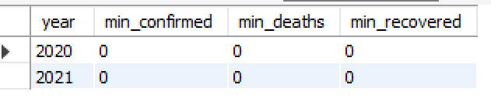

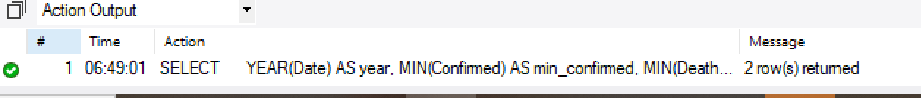

1. **Find maximum values of confirmed, deaths, recovered per year**

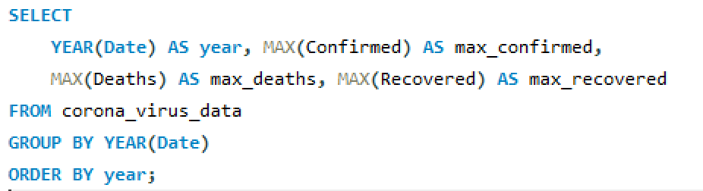

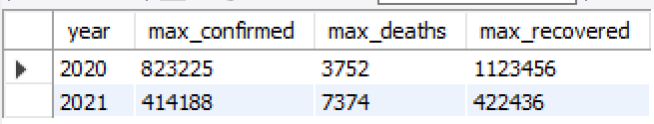

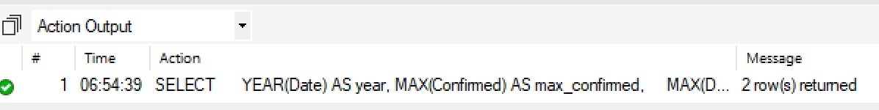

1. **The total number of case of confirmed, deaths, recovered each month**

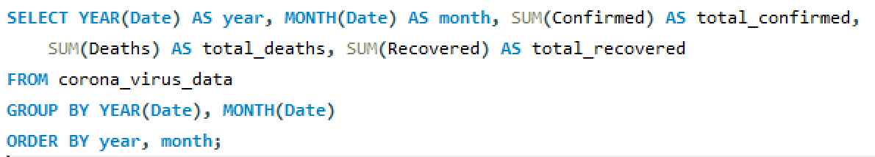

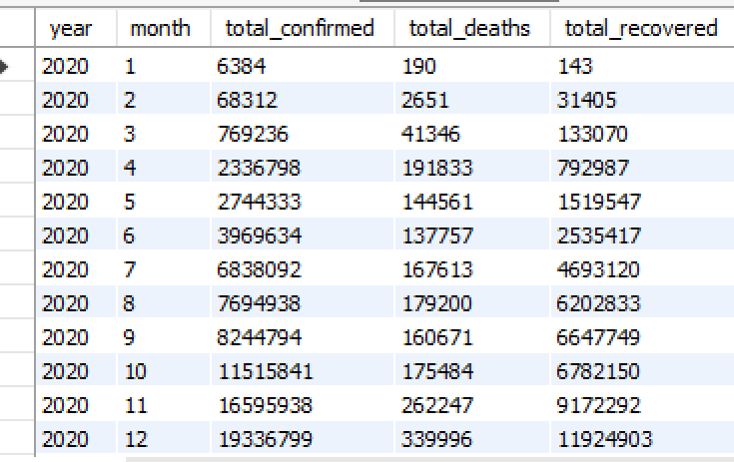

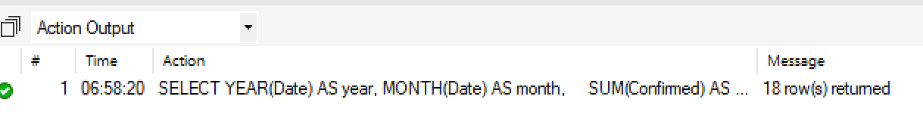

1. **Check how corona virus spread out with respect to confirmed case**

**(Eg.: total confirmed cases, their average, variance & STDEV)**

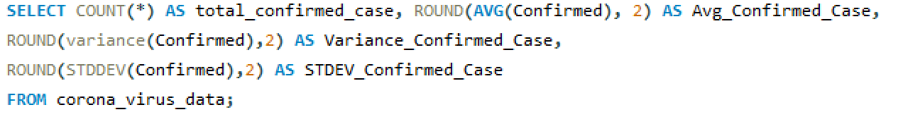

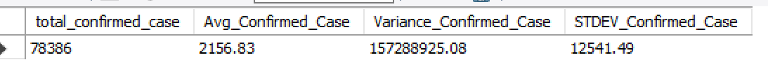

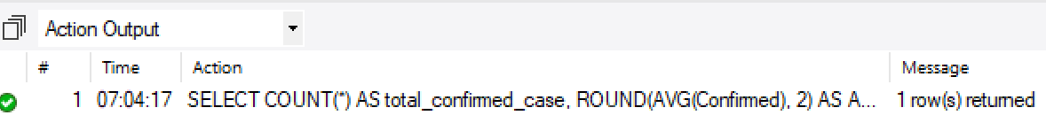

1. **Check how corona virus spread out with respect to death case per month**

**(Eg.: total confirmed cases, their average, variance & STDEV)**

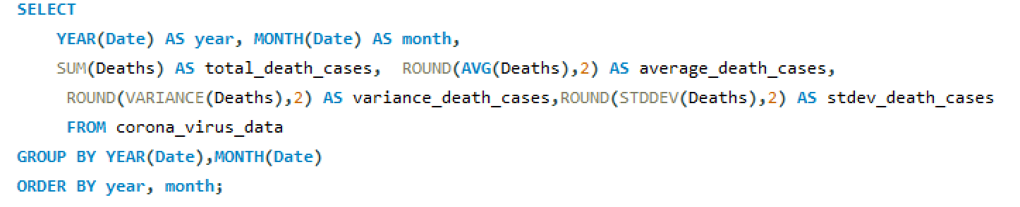

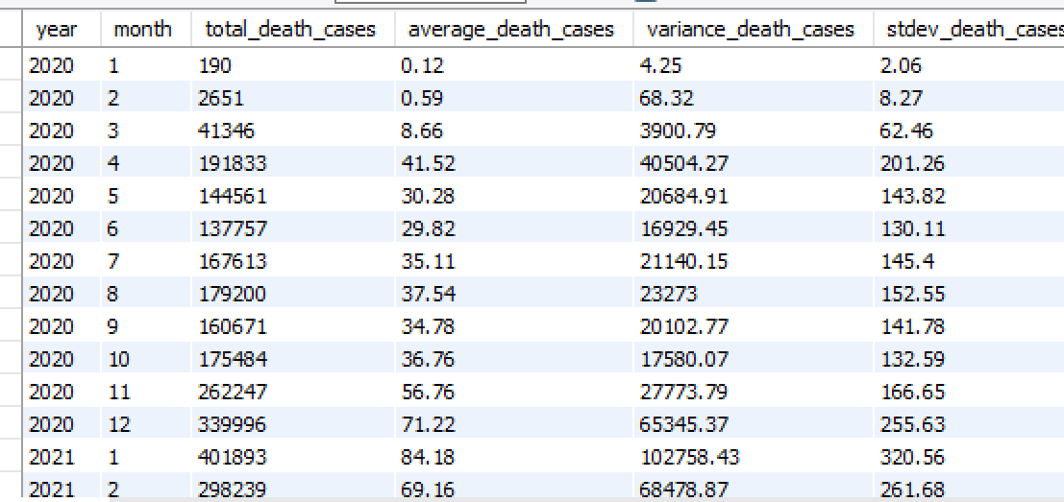

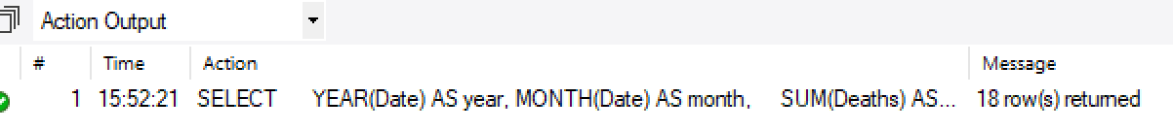

1. **Check how corona virus spread out with respect to recovered case**

**(Eg.: total confirmed cases, their average, variance & STDEV )**

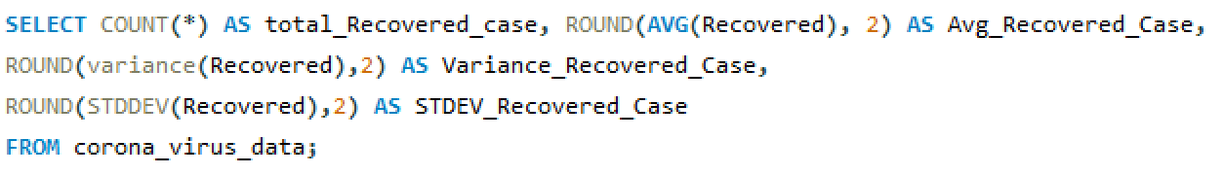



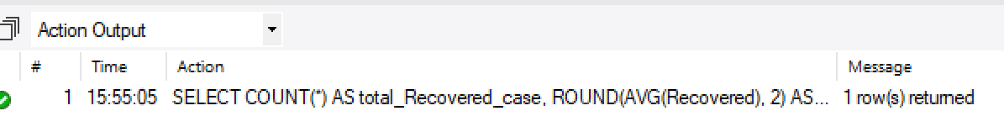

1. **Find Country having highest number of the Confirmed case**

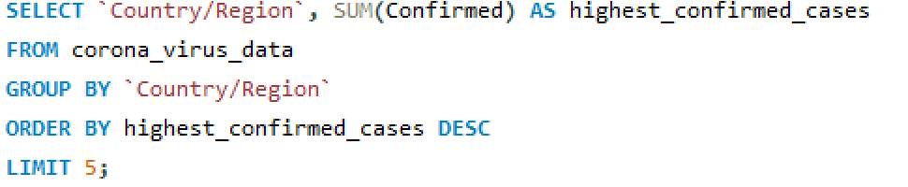

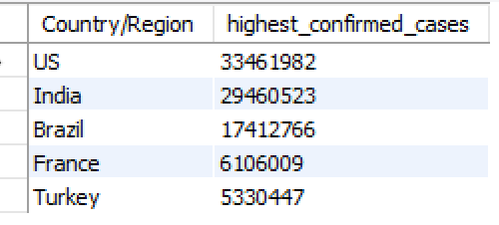

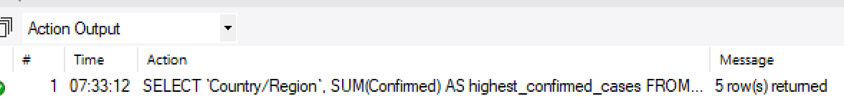

1. **Find Country having lowest number of the death case**

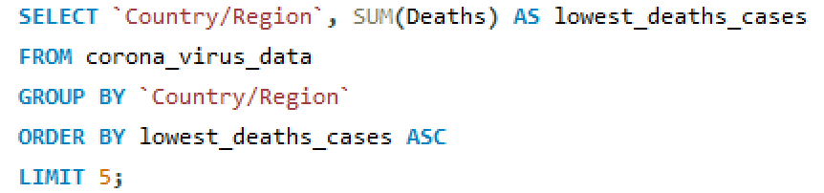

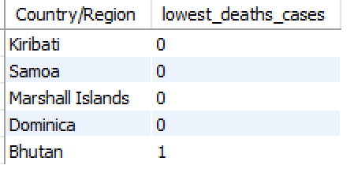

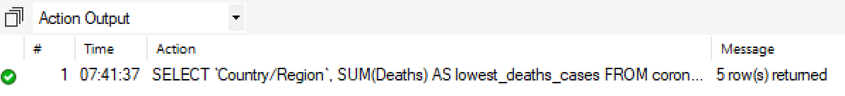

1. **Find top 5 countries having highest recovered case**

